Azure AI Search Policy-Document Chunking Implementation Guide
  - Policy Assistant RAG using Azure Blob Storage, Azure AI Search, Microsoft Foundry embeddings, and an LLM
Primary implementation point: configure chunking in the Azure AI Search skillset's - Text Split skill. Hybrid search is implemented in the application query, and semantic ranking is configured on the search index.

1. Current Architecture and Target
The current Policy Assistant RAG solution includes Azure AI Search, an Azure AI Search vector index, a Microsoft Foundry text-embedding-3-small deployment, a Microsoft Foundry chat model, Azure Blob Storage, and an ingestion pipeline from Blob Storage into Azure AI Search.
The desired initial configuration is:
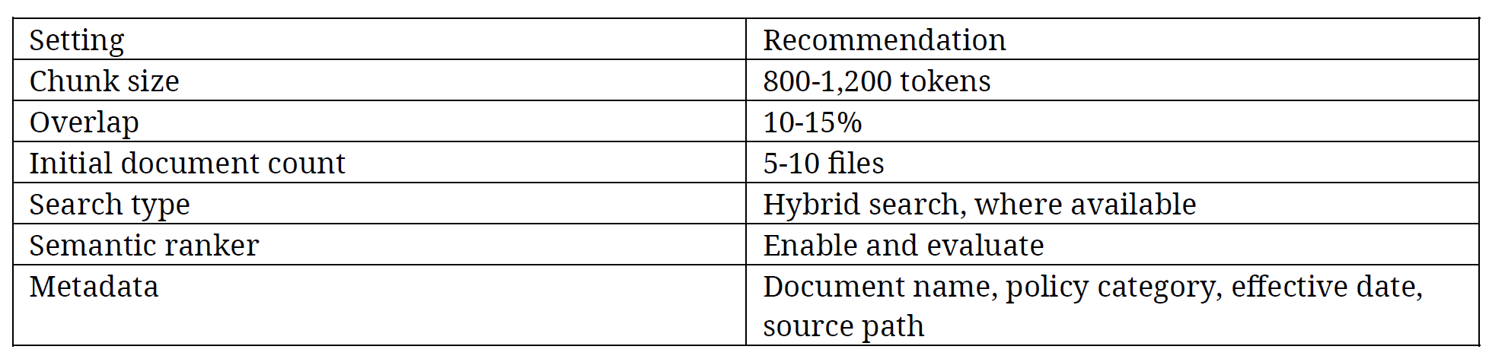

2. Where to Make the Chunking Change
Make the change in Azure AI Search, inside the skillset associated with the Blob Storage indexer. The relevant component is the Text Split skill.
The processing sequence is:
- Azure Blob Storage provides the source documents.
- The Azure AI Search indexer reads each document.
- The skillset's Text Split skill creates text chunks.
- The Azure OpenAI Embedding skill generates an embedding for each chunk.
- Index projections write one child search document per chunk into the Azure AI Search index.
Do not configure chunk size in the:
- LLM deployment
- Embedding Deployment
- Blob Storage OR
- Vector Field itself

